

Complex Computing Problem (CCP)

Project Report

RAG Based Chatbot

NAME: M. UMAR MAHMOOD GHAZNAVI
REG ID: 58020.
COURSE: PARALLEL AND DISTRIBUTED COMPUTING.
SUBMITTED TO: SIR ALI AKBAR SIDDIQUE

Chatbot Using RAG

Abstract:
This project presents a Chatbot developed using (Retrieval Augmented Generation RAG). The chatbot is designed to answer both university-related queries and general informational questions. It provides accurate and reliable responses by retrieving information from provided documents as well as handling general knowledge queries using a large language model. By combining document retrieval with generative AI, the system ensures trustworthy, context-aware, and flexible information delivery.

Introduction:
Educational institutions and users often require quick access to both official academic information and general knowledge. Searching through lengthy documents such as PDFs can be time-consuming and inefficient. This project addresses this challenge by introducing a chatbot that allows users to ask questions in natural language and receive instant, accurate answers. The chatbot supports university-specific queries as well as general questions, making it more versatile and user-friendly.

Objectives:
The main objectives of this project are:
- To develop a chatbot capable of answering questions from provided documents as well as general queries.
- To ensure document-based answers remain accurate while allowing flexibility for generic information.
- To reduce misinformation by prioritizing retrieved content where applicable.
- To provide fast, accurate, and user-friendly access to information

Technologies Used:
The following technologies are used in the development of this project:
- Python: Core programming language used for development.
- Streamlit: Used to create an interactive web-based user interface.
- LangChain: Used to implement the Retrieval Augmented Generation pipeline.
- Groq API (LLaMA 3 Model): Used as the large language model for generating answers.
- HuggingFace Embeddings: Used to convert text into numerical vector representations.
- PDF Document Loader: Used to load and process the university rules PDF file.

Methodology:
First, the relevant documents such as PDFs are loaded into the system. These documents are then split into smaller text chunks to improve retrieval efficiency. Each chunk is converted into embeddings and stored in a vector database. When a user asks a question, the system retrieves the most relevant chunks from the database if the query is document-related. The retrieved content, along with the user query, is then passed to the language model, which generates a final response. For general queries, the model can generate answers directly without document retrieval.

Retrieval Augmented Generation (RAG):
Retrieval Augmented Generation (RAG) is a technique that combines information retrieval with language generation. Instead of relying solely on pre-trained knowledge, the model first retrieves relevant information from external documents when available. This approach improves accuracy, reduces hallucinations, and ensures reliable responses, while still allowing the chatbot to answer general questions effectively.

System Architecture:
The system follows the following workflow:
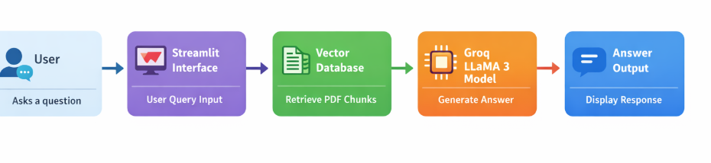

The Chatbot follows a structured Retrieval Augmented Generation (RAG) architecture to ensure accurate and context-aware answers.
The workflow begins when the user submits a query through the Streamlit web interface, which provides an interactive and user-friendly chat environment.
The system accesses available documents using a PDF Document Loader. The content is divided into smaller meaningful chunks using a Text Splitter to enhance retrieval efficiency.
Each text chunk is transformed into numerical vectors using HuggingFace Embeddings and stored in a Vector Database.
When a user asks a document-related question, the system performs a vector similarity search to retrieve the most relevant content. For general queries, the chatbot can directly generate responses using the language model.
The retrieved context and user query are then sent to the Groq LLaMA Language Model, which generates an accurate and coherent answer.
Finally, the response is displayed to the user in real time through the Streamlit interface.

Results:
The chatbot successfully handled both document-based and general queries. For document-related questions, the responses were accurate and strictly based on the retrieved content.
- The system demonstrated fast response times due to efficient embedding-based retrieval. Users were able to ask questions in natural language and receive clear, precise answers through an interactive interface.
- Testing results showed that:
- The chatbot correctly answered queries related to academic policies and regulations.
- General informational questions were answered accurately and coherently.
- The retrieval mechanism consistently selected relevant document chunks when required.
- The language model produced context-aware and reliable responses.

Future Enhancements:
The system can be further improved by:
- Adding support for multiple PDF documents, allowing users to query information from various departments or policies.
- Implementing voice-based query functionality to enhance accessibility for all users.
- Deploying the chatbot on cloud platforms to enable access from anywhere.
- Introducing user authentication for personalized experiences.
- Improving the user interface with advanced chat features and better visualization.
- Enabling real-time document updates so changes in rules are reflected automatically.

Conclusion:
This project demonstrates an effective and flexible chatbot solution using Retrieval Augmented Generation (RAG). The chatbot is capable of answering both document-based and general queries, ensuring accuracy and versatility.
By combining document retrieval with a powerful language model, the system minimizes incorrect responses and improves information accessibility. The chatbot provides a practical real-world application of RAG technology and serves as a reliable information assistant.

Supported Query Types by the Chatbot:
The chatbot supports a wide range of user queries, including:
- University-related queries
(e.g., attendance rules, examination policies, academic regulations)
- General informational queries
(e.g., definitions, explanations, basic knowledge questions)
- Policy clarification questions
(e.g., explanations of specific rules mentioned in documents)
- Document-based questions
(e.g., questions answered strictly from uploaded PDFs)
- Natural language queries
(e.g., conversational questions asked in simple language)

Links:
https://github.com/TehreemGM/MyChatbot
https://mychatbot1234.streamlit.app/

Screenshot’s:

